PES2UG21CS478 Sanskar Khatri

DS Lab 2:

Output for program 1(Create an ordered doubly linked list and search for the given information):

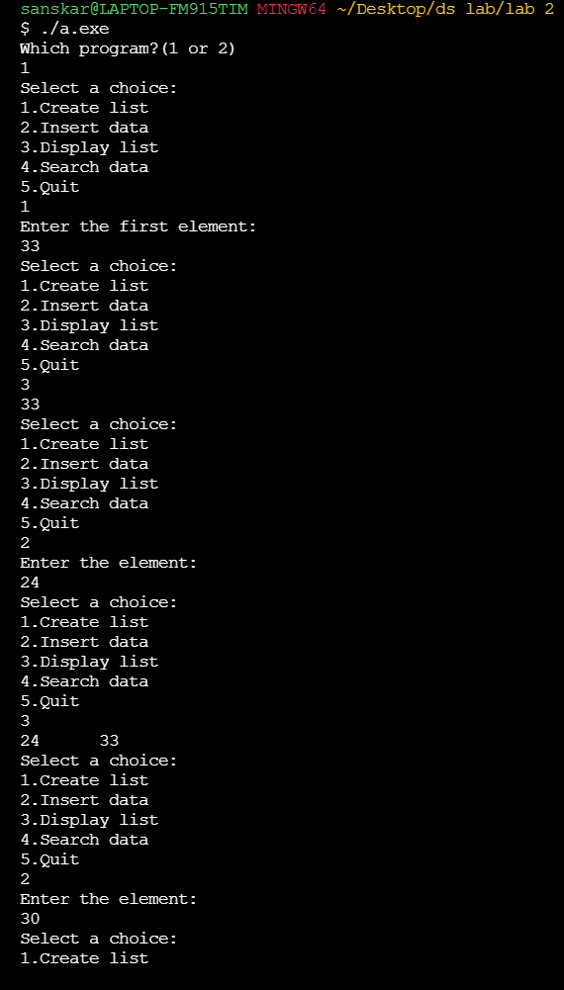

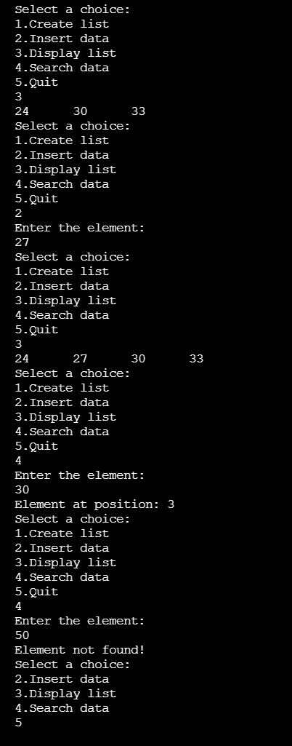

Output for program 2(Merge two ordered lists and display the merged lists):

